County of Mendocino
Steve Dunnicliff, Director
Phone: 707-234-6650
Fax: 707-463-5709
FB Phone: 707-964-5379
FB Fax: 707-961-2427
pbs@co.mendocino.ca.us
www.co.mendocino.ca.us/planning
Department of Planning and Building Services
860 North Bush Street ž Ukiah ž California ž 95482
120 West Fir Street ž Fort Bragg ž California ž 95437

Memorandum

Date: May 7, 2018

To: Mendocino Historical Review Board
From: Planning and Building Services
Subject: Establishment, Power, Duties and Responsibilities of Historical Review Board

At it’s April 2018 meeting, the Review Board asked Dan Potash to prepare a draft letter about board membership. The draft letter is attached. What follows are the current zoning code requirements.

The Mendocino Town Zoning Code Section 20.760.020 Establishment, Power, Duties and Responsibilities of Historical Review Board reads:

“There is hereby established a Historical Review Board, hereinafter called "Review Board," whose function is to preserve the architecture and character of the Historic District, whose duties are to review all applications for development as described in Sections 20.760.030 and 20.760.035, within the Historical District and whose responsibility is to protect the landmark status of buildings, ensuring development is compatible with surrounding development.
Said Review Board shall consist of five (5) members who shall be electors and residents within the Historic District and, to the extent possible, represent a cross section of the community. In making its appointment(s), the Board of Supervisors may consider the applicant's length of residency within the Historic District as an important element in the selection process.
All Review Board members shall be appointed by the Board of Supervisors to serve a term of three (3) years. No members of the Review Board shall serve more than two (2) full consecutive terms without a break in service, excluding a partial term of less than eighteen (18) months. "Break in service" as used in this section shall mean a period of not less than three (3) years after the time a person has served on the Review Board.
Review Board members must retain their eligibility under the terms of this section throughout their term of office.”
Mendocino County Board of Supervisor’s adopted regulations state:
- Membership shall consist of five persons who are electors, meaning registered voters within the Mendocino Historical Preservation District, and residents within the Historic District, which is inclusive of Zone A and B.
- Service is limited to two consecutive terms of three years.

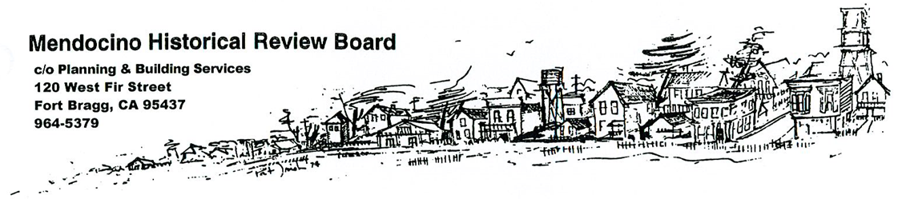
Draft Date: May 7, 2018

From: Mendocino Historical Review Board
To: Mendocino County Board of Supervisors

The Mendocino Historical Review Board (MHRB) is a five-member board consisting of volunteer residents appointed by the county board of supervisors. The zoning code limits the eligibility of board members to electors residing in Town, except for the Palette Drive neighborhood, with a limit of two consecutive terms.

In the last few years, these qualification requirements have proven to be a significant challenge in ensuring a full compliment of Review Board members. As a result, when the MHRB has only had three members, meetings have had to be cancelled when just one member has not been able to attend. The zoning code requires that most property improvements in Town secure a review and permit from MHRB. Consequently, the county is not able to meet its obligation to process applications that the County requires.

We request that the Board of Supervisors consider expanding the potential pool of qualified MHRB board members in the following three ways:

Geographically – The current zoning code does not include residents of Palette Drive from eligibility. We believe their proximity to the Historic Districts A and B makes this exclusion misguided in light of the challenges MHRB routinely faces in attracting qualified board members.

Expertise – Aside from the regular difficulties in seating the requisite number of Review Board members, MHRB and applicants themselves would benefit from reserving one of the five seats for a member who has particular and documented expertise in historic preservation, regardless of where they live. While we recognize and support the fundamental importance of local decision making, we believe that it is equally important that at least one person on the Review Board also have a proven background and expertise in the subject matter at the heart of the MHRB purpose. We are open to how best to establish minimum, verifiable standards, such as projects undertaken, education, or certification.

Experience – The zoning code limits the length that a Review Board member may serve to two consecutive 3-year terms. We acknowledge the purpose of this limitation. The fact remains, though, that the community does have a number of residents who have already gone through the learning curve necessary to be constructive board members. We believe that when the Review Board is reduced to three members, this pool of termed-out members should be available to fill in, assuming they have submitted the requisite disclosure forms prior to their temporary service.

No one of these suggested changes will solve the long term problem and responsibility of ensuring that the MHRB will always be available to review projects. But together, they provide the MHRB with the best chance of ensuring the community that the county will be able to meet its obligation to review requisite applications.

